# BLINKABLE - UI FOR THE DISABLED

*“Your shopping just a blink away”*

## A PROJECT REPORT

***Submitted by***

**RAGAVA KRISHNAN N S (21162107012201)**

**RAMANUJAN N R (2116210701206)**

**RAMKEERTHAN M A (2116210701207)**

**SAI PRASAD R (2116210701220)**

***in partial fulfillment for the award of the degree of***

**BACHELOR OF ENGINEERING**

***in***

## COMPUTER SCIENCE AND ENGINEERING



**RAJALAKSHMI ENGINEERING COLLEGE ANNA UNIVERSITY, CHENNAI**

**MAY 2024**

# RAJALAKSHMI ENGINEERING COLLEGE, CHENNAI

**BONAFIDE CERTIFICATE**

Certified that this Thesis titled **“BLAINKABLE- A DISABLED UI**” is the bonafide work of “**RAGAVA KRISHNAN N S (2116210701201), RAMANUJAN N R (2116210701206), RAMKEERTHAN (2116210701207), SAI PRASAD R (2116210701220)”** who carried out the work under my supervision. Certified further that to the best of my knowledge, the work reported herein does not form part of any other thesis or dissertation on the basis of which a degree or award was conferred on an earlier occasion on this or any other candidate.

## SIGNATURE

Vijay K B.Tech., M.E.,

Assistant Professor (SG)

## PROJECT COORDINATOR

Professor

Department of Computer Science and Engineering Rajalakshmi Engineering College

Chennai - 602 105

Submitted to Project Viva-Voce Examination held on **_**

**Internal Examiner External Examine**r

# ABSTRACT

Our project's objective is to totally change the way that individuals with disabilities shop online by integrating blink technology into an easy-to-use user interface. We have created a unique strategy that puts accessibility and independence first because we are aware of the substantial obstacles this population encounters when trying to access e-commerce sites. Thanks to the application of sophisticated blink detection technology, users can quickly traverse the shopping website and make judgments. Because of the simplicity and convenience of use of our system, disabled people may explore, choose, and buy things with little difficulty. We have customized our interface to match the various demands of impaired people through extensive user testing and iterative refinement, guaranteeing a smooth and empowering shopping experience. The tremendous positive feedback we've received from our testing rounds highlights how our platform helps users feel more confident and autonomous. Apart from mitigating existing challenges, our project establishes a novel standard for inclusive design methodologies in e-commerce. Through the combination of state-of-the-art technology and user-centered design concepts, we have developed a system that not only improves accessibility for people with disabilities but also fosters a more welcoming online community. Our method shows how, despite differences in physical ability, technology can close gaps and provide equal chances for all users. Our goal is to create a more equal and open digital environment where everyone may contribute and thrive. Our ultimate goal is to encourage other programmers and businesses to give accessibility first priority when designing their products, thus contributing to a wider trend of inclusivity in the digital realm. With the help of this initiative, we intend to significantly improve the lives of people with disabilities by giving them the confidence and ease to purchase online and opening the door for a more inclusive e-commerce industry in the future.

# ACKNOWLEDGMENT

First, we thank the almighty god for the successful completion of the project. Our sincere thanks to our chairman **Mr. S. Meganathan B.E., F.I.E.,** for his sincere endeavor in educating us in his premier institution. We would like to express our deep gratitude to our beloved Chairperson **Dr. Thangam Meganathan Ph.D.,** for her enthusiastic motivation which inspired us a lot in completing this project, and to Vice Chairman **Mr. Abhay Shankar Meganathan B.E., M.S.,** for providing us with the requisite infrastructure.

We also express our sincere gratitude to our college Principal,

**Dr. S. N. Murugesan M.E., PhD., Dr. P. KUMAR M.E., PhD, Director of Computing and Information Science, and Head Of the Department of Computer Science and Engineering** and our project coordinator **Mr. Vijay K B.Tech., M.E.,** for his encouragement and guiding us throughout the project towards successful completion of this project and to our parents, friends, all faculty members and supporting staffs for their direct and indirect involvement in successful completion of the project for their encouragement and support.

**RAGAVA KRISHNAN N S RAMANUJAN N R RAMKEERTHAN M A SAI PRASAD R**

## TABLE OF CONTENTS

| **CHAPTER NO.** | **TITLE** | **PAGE NO.** |
| --- | --- | --- |
|  | **ABSTRACT** | **iii** |
|  | **LIST OF TABLES**  **LIST OF FIGURES** | **v**  **vii** |

1. **INTRODUCTION 1**
   1. RESEARCH PROBLEM
   2. PROBLEM STATEMENT
   3. SCOPE OF THE WORK
   4. AIM AND OBJECTIVES OF THE PROJECT
   5. RESOURCES
   6. MOTIVATION

## LITERATURE SURVEY 5

* 1. SURVEY

## SYSTEM DESIGN 9

* 1. GENERAL
  2. SYSTEM ARCHITECTURE DIAGRAM
  3. SYSTEM ARCHITECTURE IN DETAIL

3.3.1 FLOW OF INTERACTIONS

* 1. DEVELOPMENT ENVIRONMENT
     1. HARDWARE REQUIREMENTS
     2. SOFTWARE REQUIREMENTS

## PROJECT DESCRIPTION 14

* 1. METHODOLOGY
  2. MODULE DESCRIPTION

## RESULTS AND DISCUSSIONS 17

* 1. FINAL OUTPUT
  2. RESULT

## CONCLUSION AND SCOPE FOR

**FUTURE ENHANCEMENT 20**

* 1. CONCLUSION
  2. FUTURE ENHANCEMENT

## REFERENCES 29

|  | **LIST OF FIGURES** |  |
| --- | --- | --- |
| **FIGURE NO** | **TITLE** | **PAGE NO** |
| 3.1 | SYSTEM ARCHITECTURE | 6 |
| 5.1 | OUTPUT | 25 |

**CHAPTER 1**

## INTRODUCTION

In a time where technology is constantly changing accessibility, our project aims to close the accessibility gap for people with disabilities when they shop online. We introduce a novel way to improve the shopping experience for people with disabilities by incorporating blink technology. Our goal is to enable customers to navigate a shopping website with ease and make selections in just a blink of an eye by utilizing the power of straightforward yet efficient blink identification.

Our project's dedication to diversity and creativity is its core. We are aware of the various needs that people with disabilities have, and we work hard to provide solutions that not only satisfy but also surpass their needs. We aim to transform the way impaired consumers engage with online buying platforms by introducing a dynamic progress indicator in conjunction with blink-based choosing. We hope to encourage self-sufficiency and autonomy in our customers by offering a smooth and user-friendly interface, enabling them to participate in the online market with ease.

The idea of user-centric design lies at the heart of our methodology. We are aware that understanding the problems and experiences of our target audience is essential to creating a workable solution. We have iteratively improved our system to make sure it satisfies the various demands of people with disabilities through in-depth study and user testing. Through the use of accessibility best practices and a focus on user feedback, we have developed a solution that not only removes current obstacles but also establishes new benchmarks for inclusive design in e-commerce.

## PROBLEM STATEMENT

Even though internet purchasing is so common, it can be very difficult for people with impairments to access and use e-commerce platforms. Frustration and exclusion result from traditional interfaces' frequent failure to provide essential adjustments for those with restricted mobility or vision impairments. By utilizing blink technology, our project seeks to close this gap by delivering a more user-friendly and accessible purchasing experience. By offering a solution that is specifically designed to meet the needs of users with disabilities, we hope to remove obstacles and advance inclusion in online buying.

## SCOPE OF THE WORK

The creation and execution of a shopping website with blink technology for people with disabilities is the main goal of our project. Creating a user-friendly interface with a dynamic progress meter and incorporating blink recognition for navigating are essential elements. Iterative changes and user feedback will be part of the testing process to guarantee usability and accessibility. In order to increase awareness of inclusive design approaches in e-commerce, the scope also includes the documentation and distribution of findings.

## AIM AND OBJECTIVES OF THE PROJECT

Our project's aim is to enable impaired people to shop online by incorporating blink technology into an intuitive user interface. By using natural blink recognition, we want to improve accessibility by empowering consumers to independently surf retail websites. Our mission is to build a more equal digital marketplace where everyone, with or without a disability, can shop with confidence and ease by encouraging inclusivity and autonomy.

## RESOURCES

A significant amount of secondary research, including evaluations of conferences, standard papers, business journals, white papers, analyst information, and accredited publications, went into developing this project. Sufficient resources are needed to finish this project successfully.

The following prospectus details a list of resources that will play a primary role in the successful execution of our project:

* + - A functional workstation (PC, laptop, netbook, etc.) for gathering pertinent information and performing research.
    - Unrestricted internet access to compile a vast array of material, such as technical documents and academic materials (e.g., tutorials, programming examples, bulletins, publications, e-books, journals, etc.).
    - Unrestricted use of academic and technical resources at university labs.
    - A Prologue developer kit to program the system of choice.
    - Additional relevant software is needed to successfully complete duties connected to research and development.

## MOTIVATION

Our endeavor is motivated by a strong belief in empowerment and inclusivity. The revolutionary potential of technology to remove obstacles for people with impairments inspires us. Observing the obstacles they encounter when attempting to access e-commerce sites inspires us to create creative solutions that put accessibility first. By utilizing blink technology, we hope to offer a seamless experience that will enable impaired customers to confidently and freely traverse the online marketplace.

Our endeavor is driven by a passion for equality and social impact. Our conviction that every person in the digital era should have equal access to opportunity drives us. Our goal is to improve the lives of people with disabilities and make a positive impact on a more equal society by creating an online purchasing environment that is more inclusive. Through our work, we hope to encourage constructive change and establish a digital space where everyone may prosper and diversity is valued.

**CHAPTER 2**

**2. LITERATURE SURVEY**

**2.1 SURVEY**

[1]Smilkov, Daniel, Nikhil Thorat, Yannick Assogba, Charles Nicholson, Nick Kreeger, Ping Yu, Shanqing Cai et al. "Tensorflow. js: Machine learning for the web and beyond." *Proceedings of Machine Learning and Systems* 1 (2019): TensorFlow.js is a library for building and executing machine learning algorithms in JavaScript. TensorFlow.js models run in a web browser and in the Node.js environment. The library is part of the TensorFlow ecosystem, providing a set of APIs that are compatible with those in Python, allowing models to be ported between the Python and JavaScript ecosystems. TensorFlow.js has empowered a new set of developers from the extensive JavaScript community to build and deploy machine learning models and enabled new classes of on-device computation. This paper describes the design, API, and implementation of TensorFlow.js, and highlights some of the impactful use cases

[2]Zhou, Zhi-Hua, and Xin Geng. "Projection functions for eye detection." *Pattern recognition* 37, no. 5 (2004): In this paper, the generalized projection function (GPF) is defined. Both the integral projection function (IPF) and the variance projection function (VPF) can be viewed as special cases of GPF. Another special case of GPF, i.e. the hybrid projection function (HPF), is developed by experimentally determining the optimal parameters of GPF. Experiments on three face databases show that IPF, VPF, and HPF are all effective in eye detection. Nevertheless, HPF is better than VPF, while VPF is better than IPF. Moreover, IPF is found to be more effective on occidental than on oriental faces, and VPF is more effective on oriental than on occidental faces. Analysis of the detections shows that this effect may be owed to the shadow of the noses and eyeholes of different races of people.

[3]Wang, Peng, Matthew B. Green, Qiang Ji, and James Wayman. "Automatic eye detection and its validation." (2005): In this paper, we first study the impact of eye locations on face recognition accuracy, and then introduce an automatic technique for eye detection. The performance of the automatic eye detection technique is subsequently validated using the FRGC 1.0 database. The validation shows that the eye detector has an overall 94.5% eye detection rate, with the detected eyes very close to the manually provided eye positions. In addition, the face recognition performance based on the automatic eye detection is shown to be comparable to that of using manually given eye positions.

[4]Zhu, Zhiwei, Kikuo Fujimura, and Qiang Ji. "Real-time eye detection and tracking under various light conditions."(2002): This paper presents a system for real-time eye detection and tracking that functions effectively under various lighting conditions. Utilizing advanced image processing techniques, the system can accurately identify and follow eye movements, ensuring reliable performance despite changes in ambient light. The robustness of the system makes it suitable for applications such as driver fatigue monitoring and human-computer interaction, where consistent eye tracking is critical.

[5]Zhu, Zhiwei, and Qiang Ji. "Robust real-time eye detection and tracking under variable lighting conditions and various face orientations."(2005): Most eye trackers using active IR illumination rely on the bright pupil effect, but factors like eye closure, occlusion, and external light can hinder their performance. This paper introduces an integrated eye tracker that combines appearance-based object recognition with active IR illumination to robustly track eyes under various lighting conditions and face orientations. It effectively handles occlusion, glasses, and can simultaneously track multiple people at different distances and poses. Extensive experiments demonstrate significant improvements over existing eye-tracking methods

[6]Li, Zewen, Fan Liu, Wenjie Yang, Shouheng Peng, and Jun Zhou. "A survey of convolutional neural networks: analysis, applications, and prospects."(2021) : This paper covers the history of Convolutional Neural Networks (CNNs), various convolution techniques, key innovations in classic and advanced CNN models, experimental insights, and practical guidelines for function and hyperparameter selection. It also explores applications of 1-D, 2-D, and multidimensional convolutions across different domains, providing a comprehensive yet concise overview of CNN development and usage

[7]Polatsek, Patrik. "Eye blink detection." *Slovak University of Technology in Bratislava. Faculty of Informatics and Information Technologies. IIT. SRC* 18 (2013): The goal of this work is to design an eye blink detector for a dry eye prevention system. Available blink detection techniques were analyzed, leading to the development of solutions based on histogram back-projection and optical flow methods. The algorithms were tested on various datasets under different lighting conditions. The inner movement detection method using optical flow outperformed the histogram-based methods, achieving a higher recognition rate and significantly lower false positive rate

[8]Morris, Tim, Paul Blenkhorn, and Farhan Zaidi. "Blink detection for real-time eye tracking." *Journal of Network and Computer Applications* 25, no. 2 (2002): This work aims to enable non-contact head and eye-based control of computer systems for individuals with motor difficulties. The system employs spatio-temporal filtering and variance maps to locate the head and identify eye-feature points. These points are tracked using a modified Lucas–Kanade tracking algorithm with pyramidal implementation. The system achieves accurate head and eye tracking at over 30 frames per second in more than 90% of cases, with a low false positive blink detection rate of 0.01%, under varying lighting conditions and for people of different ethnicities, with or without glasses.

[9]Mohammed, Assist Aree A. "Efficient eye blink detection method for disabled-helping domain." *International Journal of Advanced Computer Science and Applications* 5, no. 5 (2014): In this paper, we present a real-time method based on some video and image processing algorithms for eye blink detection. The motivation of this research is the need of disabling who cannot control the calls with human mobile interaction directly without the need for hands. A Haar Cascade Classifier is applied for face and eye detection to get eye and facial axis information. In addition, the same classifier is used based on Haar-like features to find out the relationship between the eyes and the facial axis for positioning the eyes.

## CHAPTER 3 SYSTEM DESIGN

* 1. **GENERAL**

In this section, we would like to show how the general outline of how all the components end up working when organized and arranged together. It is further represented in the form of a flow chart below.

## SYSTEM ARCHITECTURE DIAGRAM

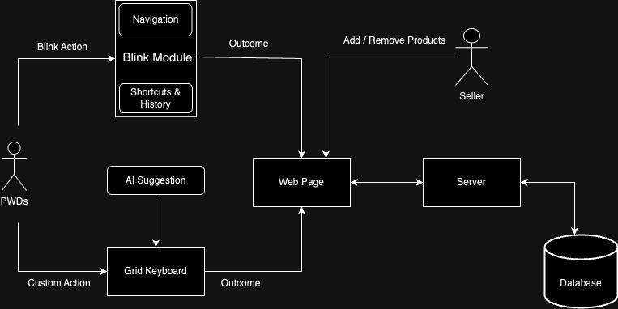

**Fig 3.1: System Architecture**

## SYSTEM ARCHITECTURE IN DETAIL

**1. Blink Module**

The Blink Module is the core component that captures and interprets blink actions from the user. It consists of two subcomponents:

**Navigation:** This subcomponent helps users navigate through the web pages by interpreting their blink actions as commands to move through menus and options.

**Shortcuts & History:** This subcomponent provides quick access to frequently used functions and maintains a history of user actions to streamline the shopping process.

**2. AI Suggestion**

This component provides intelligent suggestions based on user behavior and preferences. It learns from the user's interactions and helps predict what the user might want to do next, offering contextual assistance and suggestions.

**3. Grid Keyboard**

The Grid Keyboard is an on-screen keyboard that users can control through custom actions (e.g., eye blinks). It allows users to input text, such as search queries or other necessary information, by selecting letters or commands.

**4. Web Page**

The web page acts as the user interface where users can view products, make selections, and perform transactions. It communicates with the Blink Module to receive and execute the Blink actions.

**5. Server**

The server handles the backend processing, including managing the database of products and user information. It receives requests from the web page, processes them, and sends back the necessary data or confirmation of actions taken (e.g., adding or removing products).

**6. Database**

The database stores all the necessary information, such as product details, user profiles, transaction histories, and other relevant data. It is accessed by the server to retrieve or update information as needed.

**7. Seller Interface**

Sellers use this interface to add or remove products from the database. This ensures that the product listings are up-to-date and accurate.

**3.3.1 FLOW OF INTERACTIONS**

**1. User Interaction:** A PWD uses blink actions to interact with the Blink Module.

**2. Blink Module Processing:** The Blink Module interprets these actions and provides outcomes, such as navigating to different sections of the web page.

**3. AI Suggestions and Grid Keyboard:** The AI Suggestion component assists the user by providing contextual help, while the Grid Keyboard allows text input through custom actions.

**4. Web Page Update:** The interpreted actions lead to outcomes on the web page, such as displaying a new set of products.

**5. Server Communication:** The web page communicates with the server to fetch or update data.

**6. Database Interaction:** The server accesses the database to retrieve or store information.

**7. Seller Updates:** Sellers update the product listings in the database, which are then available for the users to view on the web page.

This architecture ensures a seamless interaction for users with disabilities, allowing them to perform online shopping activities efficiently with minimal physical input.

## DEVELOPMENTAL ENVIRONMENT

* + 1. **HARDWARE REQUIREMENTS**

The hardware requirements may serve as the basis for a contract for the system’s implementation. It should therefore be a complete and consistent specification of the entire system. It is generally used by software engineers as the starting point for the system design. Furthermore, it will also require a special keyboard that is called Grip Keyboard for custom actions for the PWDs.

| **COMPONENTS** | **SPECIFICATION** |
| --- | --- |
| PROCESSOR | Intel Core i3 |
| RAM | 4 GB RAM |
| HARD DISK | 256 GB |
| PROCESSOR SPEED | MINIMUM 1.1 GHz |

## Table 3.1 Hardware Requirements

* + 1. **SOFTWARE REQUIREMENTS**

The software requirements document is the specifications of the system. It should include both a definition and a specification of requirements. It is a set of what the system should rather be doing than focus on how it should be done. The software requirements provide a basis for creating the software requirements specification. It is useful in estimating the cost, planning team activities, performing tasks, tracking the team, and tracking the team’s progress throughout the development activity.

**Any browser like Chrome, Safari or Firefox** would be required

**CHAPTER 4**

**4. PROJECT DESCRIPTION**

## METHODOLOGY

## 

## Research Design

## The project will follow a design and development research methodology, incorporating both quantitative and qualitative methods. The primary objective is to design, develop, and evaluate a blink-based shopping system.

## Requirements Analysis

## Conduct surveys and interviews with potential users, especially those with mobility impairments, to gather requirements and preferences for the system.

## System Design

## Develop the system architecture, including the client application, server infrastructure, and database design.

## Create wireframes and prototypes for the user interface, ensuring accessibility and ease of use.

## Technology and Tools

## Use programming languages such as Python and TensorFlow for JavaScript framework for blink detection algorithms, and web development frameworks for the user interface.

## System Implementation

## Develop and train a machine learning model to accurately detect blinks using data from the eye-tracking device.

## Integrate the blink detection algorithm with the shopping system's user interface to allow users to navigate and select products using blinks.

## Data Collection Methods

## Conduct usability testing with a group of participants to evaluate the system’s performance and user experience.

## Collect feedback through observation, questionnaires, and interviews.

## Measure system performance metrics such as blink detection accuracy, response time, and error rates.

## Data Analysis Techniques

## Analyze performance metrics using statistical methods to evaluate the accuracy and efficiency of the blink detection system.

## Analyze feedback from user testing to identify usability issues and areas for improvement.

## MODULE DESCRIPTION

**User Interface (UI) Module**

This module provides the front-end interface that users interact with. It includes the visual elements and navigational structure of the shopping platform, optimized for use with blink input.

**Eye-Tracking and Blink Detection Module**

This module is responsible for tracking the user’s eye movements and detecting blinks, converting them into actionable commands for navigating and interacting with the UI.

**Backend Server Module**

This module handles the business logic, data processing, and communication between the front end and the database. It ensures secure and efficient operations of the shopping system.

**Database Module**

This module is responsible for storing and managing all the data required by the system, including user information, product details, and transaction records.

**Security Module**

This module ensures the security and privacy of the system, protecting user data and transactions from unauthorized access and breaches.

**Testing and Quality Assurance (QA) Module**

This module focuses on ensuring the system is reliable, efficient, and free from bugs through rigorous testing and validation processes.

## CHAPTER 5

**5. RESULTS AND DISCUSSIONS**

## OUTPUT

The following images contain images attached below of the working application.



The Green Dot on the navigation bar is clicked inorder to select the green bar on next. This makes the current highlighted anchor to the next image given.

## 

## Fig 5.1.1: Output



Now again the green dot acts as a singular input for the whole page. On selecting the In option we are able to go inside the main content of the page.

**Fig 5.1.2:** Navigation using NEXT for Section ok ok

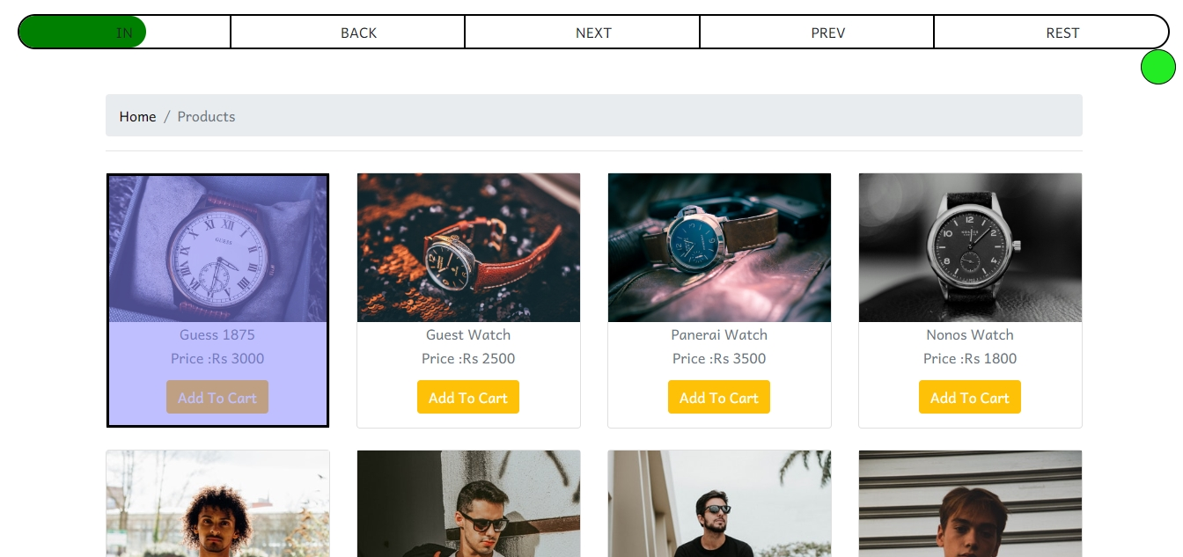

As we go inside the main content we are directed highlighted the items of the shop. This website allows the feature of auto scrollable which is one of the import feature. The next option on selection helps us go to the next item on the list.

**Fig 5.1.3:** Navigation using IN for selection

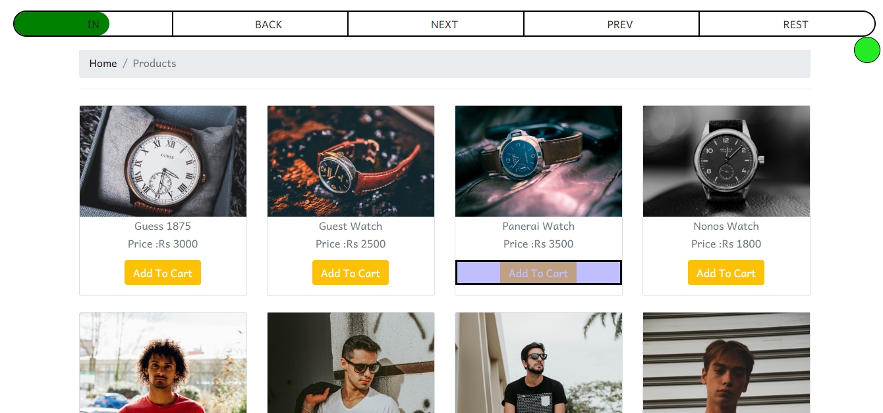

This image accounts for the clickable feature of the site. The In bar is used to click a button. From the previous image, we go to the next items. Upon viewing the required item we again go In which selects the button and then inorder to chick the button we choose the click option.

**Fig 5.1.4:** Navigation using IN for Clicks

* 1. **RESULT**

The incorporation of blink technology with our intuitive interface has produced revolutionary results, transforming the way that people with disabilities purchase online. Through extensive user testing and iterative improvement, accessibility and autonomy have been successfully prioritized in our system. Now, customers may choose their options with just an eyeblink while navigating the purchasing website with ease. This creative method has not only removed obstacles but also established a new benchmark for inclusive design in e-commerce.

User feedback has been largely favorable, with many reporting increased self-assurance and independence when interacting with the online marketplace. The smooth incorporation of blink recognition technology has enabled impaired people to shop online with confidence, promoting equality and inclusivity in the digital sphere. With the help of our initiative, a more accessible and equitable digital environment will be built, enabling people of all abilities to engage in and profit from online trade. Going forward, these findings highlight how crucial it is to give accessibility top priority when creating digital platforms.

## CHAPTER 6

**6. CONCLUSION AND FUTURE ENHANCEMENT**

## 6.1 CONCLUSION

The development of a blink-based shopping system represents a significant advancement in accessibility technology, particularly for individuals with limited mobility. This methodology outlines a comprehensive approach to creating a user-friendly system that leverages eye-tracking and blink-detection technology to enable seamless online shopping experiences.

By systematically addressing user and technical requirements, designing an intuitive user interface, and implementing robust blink detection algorithms, the project aims to create a reliable and efficient system. The integration of qualitative and quantitative research methods ensures a thorough evaluation of the system's performance and usability, providing valuable insights for continuous improvement.

Ethical considerations, including informed consent and data privacy, are paramount to the project's success, ensuring that user trust and safety are maintained. Acknowledging the limitations and outlining future work underscores the commitment to ongoing innovation and enhancement of the system.

In conclusion, the blink-based shopping system has the potential to transform the way individuals with mobility impairments interact with online shopping platforms, promoting greater independence and inclusivity. This project not only addresses a specific accessibility need but also contributes to the broader goal of creating more inclusive digital environments. By continuing to refine and expand upon this foundation, the system can evolve to meet the diverse needs of its users, ultimately enhancing the quality of life for many.

## 6.2 FUTURE ENHANCEMENT

A potential future enhancement for our online shopping platform using blink technology could involve incorporating more advanced AI techniques or expanding the platform’s features to create a more immersive and user-friendly experience for disabled individuals

## Dynamic Assistance and Customization:

Implement a system that dynamically adjusts the platform's assistance and customization features based on the user's performance and preferences. This enhancement could involve:

1. **Personalized Navigation:** Develop interface behavior that adapts based on the user's navigation patterns and preferences. The system could dynamically adjust the speed of the progress bar, the sensitivity of blink detection, and the order of displayed categories or items, providing a customized and enjoyable experience for users of varying preferences and abilities.
2. **User Proficiency Tracking:** Skill-Based Customization: Implement a system where the platform assesses the user's proficiency over time. As the user becomes more adept at using the blink technology, the interface can gradually introduce more advanced features or faster navigation options.

**APPENDIX**

**SOURCE CODE:**

<div id="TimedBarParent" class="fixed-top">

<div id="TimedBarOutline">

<div id="TimedBar"></div>

<div class="inner-outline">

<div>IN</div>

<div>BACK</div>

<div>NEXT</div>

<div>PREV</div>

<div>REST</div>

</div>

</div>

<div id="clickZone">

</div>

</div>

<script src="https://code.jquery.com/jquery-3.7.1.js"></script>

<script>

$(document).ready(()=>{

let width=0;

let distance = 1;

let time = 50;

setInterval(()=>{

width=(width+distance)%100;

$('#TimedBar').css('width',width+"%");

},time);

let pageQueue = [];

const removeHightLight = ()=>{

$(document).find('#highlighter').remove();

}

const addHighLight = ()=>{

$(pageQueue[pageQueue.length-1]).after('<div id="highlighter"></div>')

let top = $(pageQueue[pageQueue.length-1]).parent().offset().top;

$(document.body).scrollTop($(pageQueue[pageQueue.length-1]).parent().offset().top);

window.scrollTo({

top:top-200,

behavior:"smooth"

})

}

const push = (ele)=>{

removeHightLight();

pageQueue.push(ele);

addHighLight();

}

const pop = ()=>{

removeHightLight();

pageQueue.pop();

addHighLight();

}

const goIN = ()=>{

let parent = $(pageQueue[pageQueue.length-1]).parent()

let anchors = parent.find(".anchor");

if(anchors.length>1){

push(anchors[1]);

}

else{

parent[0].click();

}

}

const goBack = ()=>{

if (pageQueue.length>1){

pop()

}

}

const goNext = ()=>{

if(pageQueue.length>1){

let currAnchor = pageQueue[pageQueue.length-1];

let parentAnchor = pageQueue[pageQueue.length-2]

let anchorsParO = $(parentAnchor).parent().find(".anchor");

let anchorsCurO = $(currAnchor).parent().find(".anchor");

let anchorsPar = [];

for(let i = 0;i<anchorsParO.length;i++)anchorsPar.push(anchorsParO[i]);

let anchorsCur = [];

for(let i = 1;i<anchorsCurO.length;i++)anchorsCur.push(anchorsCurO[i]);

let difference = anchorsPar.filter(x => !anchorsCur.includes(x));

let currIndex = difference.indexOf(currAnchor);

if(currIndex+1!=difference.length){

pop()

push(difference[currIndex+1]);

}

}

}

const goPrev = ()=>{

if(pageQueue.length>1){

let currAnchor = pageQueue[pageQueue.length-1];

let parentAnchor = pageQueue[pageQueue.length-2]

let anchorsParO = $(parentAnchor).parent().find(".anchor");

let anchorsCurO = $(currAnchor).parent().find(".anchor");

let anchorsPar = [];

for(let i = 0;i<anchorsParO.length;i++)anchorsPar.push(anchorsParO[i]);

let anchorsCur = [];

for(let i = 1;i<anchorsCurO.length;i++)anchorsCur.push(anchorsCurO[i]);

let difference = anchorsPar.filter(x => !anchorsCur.includes(x));

let currIndex = difference.indexOf(currAnchor);

if(currIndex-1!=-1){

pop()

push(difference[currIndex-1]);

}

}

}

pageQueue.push($(document.body).find(".anchor")[0]);

addHighLight();

$('#clickZone').click(()=>{

if(width<20){

goIN();

width=0;

}

else if(width<40){

goBack();

width=0;

}

else if(width<60){

goNext();

width=0;

}

else if(width<80){

goPrev();

width=0;

}

else{

}

})

})

</script>

## REFERENCES

* 1. Smilkov, Daniel, Nikhil Thorat, Yannick Assogba, Charles Nicholson, Nick Kreeger, Ping Yu, Shanqing Cai et al. "Tensorflow. js: Machine learning for the web and beyond." *Proceedings of Machine Learning and Systems* 1 (2019): 309-321.
  2. Zhou, Zhi-Hua, and Xin Geng. "Projection functions for eye detection." *Pattern recognition* 37, no. 5 (2004): 1049-1056.
  3. Wang, Peng, Matthew B. Green, Qiang Ji, and James Wayman. "Automatic eye detection and its validation." In *2005 IEEE Computer Society Conference on Computer Vision and Pattern Recognition (CVPR'05)-Workshops*, pp. 164-164. IEEE, 2005.
  4. Zhu, Zhiwei, Kikuo Fujimura, and Qiang Ji. "Real-time eye detection and tracking under various light conditions." In *Proceedings of the 2002 symposium on Eye tracking research & applications*, pp. 139-144. 2002.
  5. Zhu, Zhiwei, and Qiang Ji. "Robust real-time eye detection and tracking under variable lighting conditions and various face orientations." *Computer Vision and Image Understanding* 98, no. 1 (2005): 124-154.
  6. Li, Zewen, Fan Liu, Wenjie Yang, Shouheng Peng, and Jun Zhou. "A survey of convolutional neural networks: analysis, applications, and prospects." *IEEE transactions on neural networks and learning systems* 33, no. 12 (2021): 6999-7019.
  7. Polatsek, Patrik. "Eye blink detection." *Slovak University of Technology in Bratislava. Faculty of Informatics and Information Technologies. IIT. SRC* 18 (2013): 1.
  8. Morris, Tim, Paul Blenkhorn, and Farhan Zaidi. "Blink detection for real-time eye tracking." *Journal of Network and Computer Applications* 25, no. 2 (2002): 129-143.
  9. Mohammed, Assist Aree A. "Efficient eye blink detection method for disabled-helping domain." *International Journal of Advanced Computer Science and Applications* 5, no. 5 (2014).